SAP Implementation Project
At
Government of Andhra Pradesh



Project CFMS
(Comprehensive Financial Management System)

Technical Design Document
EXPENDITURE SUMMARY REPORT

Document Version : 1.1
Document Release Date : 29th September, 2018

Only for internal use

Table of Content
1. Introduction 3
1.1 Purpose of this document 3
1.2 Scope of this document 3
2. Document Identification 3
3. Document History 4
4. Process Description 5
5. Reporting Scope 5
6. Functionality Requirements 6
7. TECHNICAL REQUIREMENTS - REPORTS 6
7.1 WebI Basic Overview: Annexure Expenditure Summary Report 6
7.2 WebI Basic Overview: Annexure Expenditure Monthly Comparison Report 7
7.3 WebI Basic Overview: Annexure Expenditure Quarterly Comparison Report 7
7.4 WebI Basic Overview: Annexure Expenditure HOA Report 7
8. TECHNICAL REQUIREMENTS - REPORTS 8
8.1 Objects, Variable and Report Controls used 8
8.2 Expenditure Summary Report Level Calculations and Formulas used 13
8.3 Expenditure Monthly Comparison Report Level Calculations and Formulas used 15
8.4 Expenditure HOA Report Level Calculations and Formulas used 22
8.5 Expenditure Quarterly Comparison Report Level Calculations and Formulas used 24
8.6 Charts 29
8.7 Expenditure Report with HOA Level 31
Appendix A - 34
Appendix B - 34

Introduction

Purpose of this document
The purpose of this document is to describe the Technical Design of EXPENDITURE SUMMARY, EXPENDITURE MONTHLY COMPARISON, EXPENDITURE QUARTELY COMPARISON, HOA, CHARTS at CFMS( Comprehensive Finance Management System ) for Department of Finance , Govt.of Andhra Pradesh.

Scope of this document
This document contains the technical description and design of EXPENDITURE SUMMARY REPORT.

Document Identification
Document details
Project Name | Module | Business Scenario -
GoAP | Business Objects | Expenditure
Module Lead – GoAP | Module Lead – SAP/Partner | Process Owner
 | Manoj Dhir
BBP Number | BBP Name
 | BO Reports

Document History

Authors & Participants
Role |  | Names
Core Team Member
Consultant |  | Nageswara Rao Adabala
Business Process Owner / FICO Lead
Workshop Participants
Revision History
Date | Document Version | Document Revision Description |  | Author
5/7/2018 | 1.0 | Draft for Internal Technical review |  | Prakash Sanju S V
6/9/2018 | 1.1 | BE Analysis Report Budget Total Decimals are Corrected,Monthly/Quarterly Comparisons and Charts are added,HOA report is added |  | Pradeep Kumar
Reviewed and Approved By
Name | Title | Date |  | Approved

Process Description

Business Process: Expenditure Summary Report
This “Expenditure Summary Report” gives information about state wise expenditure summary and quarter wise totals of category and sub category.

Business Process: Expenditure Monthly Comparison Report
This “Expenditure Monthly Comparison Report” gives information about state wise expenditure summary and monthly wise totals of category and sub category by comparing this year monthly wise expenditure to previous year monthly wise expenditure.

Business Process: Expenditure Quarterly Comparison Report
This “Expenditure Quarterly Comparison Report” gives information about state wise expenditure and monthly wise totals of category and sub category by comparing this year quarterly wise expenditure to previous year quarterly wise expenditure.

Business Process: Expenditure HOA
This “Expenditure HOA Report” gives information on HOA, Gross Amount, Major Head, Sub Major Head, Minor Head, Group Sub Head, Sub Head, Detailed Head, Sub Detailed Head.

Business Process: Expenditure HOA Details
This “Expenditure HOA Details Report” gives information on HOA, Bill Number, Bill Date and Gross Amount with HOA Codes.

Business Process: Charts
This “Charts Report” gives Comparison of state wise expenditure in month wise and quarter wise of present year and previous year. One Chart explains the Budget and Expenditure of several departments.

Reporting Scope

Expenditure Summary Report

This Report displays category/subcategory wise Expenditure, Budget Estimation, and Total Provision for the current fiscal Year to till date and total wise Expenditure from previous year to till date.

Expenditure Monthly Comparison Report

This Report displays category/subcategory wise Expenditure, Budget Estimation and Total Provision for monthly wise comparison of previous year to till date and total wise Expenditure from previous year to till date.

Expenditure Quarterly Comparison Report

This Report displays category/subcategory of Expenditure Totals in quarterly wise and year wise of previous year to till date.Growth Percentage is also displayed in quarterly wise and year wise of previous year and current year.

Expenditure HOA Report

This Report displays information of Major Head, Minor Head, Sub Head, Detailed Head, and other Sub heads, Gross Amount of Particular HOA‘s of Category and Sub Category wise.

Expenditure HOA Details Report

This Report displays HOA, Bill Number, Bill Date and Gross Amount with HOA Codes, which generated by Hyperlink embeded on to the Expenditure Detail Report.

Expenditure Charts Report

This Report displays state wise expenditure in month wise and quarter wise of previous year and
Present year.It displays Budget and Expenditure of several departments.

Functionality Requirements

DESCRIPTION | CATEGORY
Report Name | Expenditure Summary Report & Expenditure Monthly and Quarterly Comparision Report,Charts,HOA Reports
Objective/Purpose/Business Use | Reporting and Analysis
End Users/Beneficiary | Management
Frequency | Refresh on Demand
Reporting Tools | WebI
Export Format- Excel/Pdf/ | Excel/PDF
Scheduling Required: Y/N | NA

TECHNICAL REQUIREMENTS - REPORTS

WebI Basic Overview: Annexure Expenditure Summary Report
DESCRIPTION | CATEGORY
Filter | NA
Dimension (Fields) | Hoa_sub_cat_hier , Fiscal Year, Month, Quarter
Measure(Value) | Budget Estimate, Expenditure, Total Provision
Drill Down Hierarchies | HOA_SUB_CAT_HIER
Sorting | Applied on Sub Category, Sub Sub category
Conditional Formatting | Applied on number columns to attain Indian numbering format.
Breaks | Can be applied
Sections | NA

WebI Basic Overview: Annexure Expenditure Monthly Comparison Report
DESCRIPTION | CATEGORY
Filter | NA
Dimension (Fields) | Hoa_type_hier,Fiscal Year, Month, Quarter
Measure(Value) | Budget Estimate, Expenditure, Total Provision,Expenditure(Total)
Drill Down Hierarchies | HOA_TYPE_HIER
Sorting | Applied on Category, Sub Category,Sub Sub Category
Conditional Formatting | Applied on number columns to attain Indian numbering format.
Breaks | Can be applied
Sections | NA

WebI Basic Overview: Annexure Expenditure Quarterly Comparison Report
DESCRIPTION | CATEGORY
Filter | NA
Dimension (Fields) | Hoa_sub_cat_hier,Fiscal Year, Month, Quarter
Measure(Value) | Budget Estimate, Expenditure, Total Provision,Expenditure(Total)
Drill Down Hierarchies | HOA_SUB_TYPE_HIER
Sorting | Applied on Category, Sub Category,Sub Sub Category
Conditional Formatting | Applied on number columns to attain Indian numbering format.
Breaks | Can be applied
Sections | NA

WebI Basic Overview: Annexure Expenditure HOA Report
DESCRIPTION | CATEGORY
Filter | NA
Dimension (Fields) | Detailed Head, Group Sub Head, Posting Date, Major Head, Minor Head, Sub Detailed Head, Sub Head, Sub Major Head, HOA
Measure(Value) | Expenditure
Drill Down Hierarchies | NA
Sorting | Applied on HOA Category, HOA Sub Category, HOA Sub Sub Category
Conditional Formatting | Applied on number columns to attain Indian numbering format.
Breaks | Can be applied
Sections | NA

8. TECHNICAL REQUIREMENTS - REPORTS

Objects, Variable and Report Controls used.

List of HANA-Objects and View Types.

EXPENDITURE SUMMARY & MONTHLY/QUARTERLY COMPARISON & CHARTS

HANA VIEW NAME | OBJECTS | OBJECT  TYPE | VIEW  TYPE
CV_EXP_SUMMARY | Fiscal Year | String | Detail
CV_EXP_SUMMARY | EXPENDITURE | Numeric | Measure
CV_EXP_SUMMARY | HOA_TYPE_HIER (EXP-MONTHLY ) | String | Dimension
CV_EXP_SUMMARY | HOA_SUB_CAT_HIER (EXP-SUMMARY ) | String | Dimension
CV_EXP_SUMMARY | HOA_SUB_CAT_HIER (EXP-QUARTERLY ) | String | Dimension
CV_EXP_SUMMARY | RH_HOA_SUB_CAT (CHARTS ) | String | Dimension
CV_EXP_SUMMARY | EXPENDITURE IN CRORES (CHARTS ) | Numeric | Measure
CV_EXP_SUMMARY | BUDGET IN CRORES (CHARTS ) | Numeric | Measure
CV_EXP_SUMMARY | Quarter | String | Detail
CV_EXP_SUMMARY | Expenditure (Total) | Numeric | Measure
CV_EXP_SUMMARY | Month | String | Detail
CV_EXP_SUMMARY | Budget Estimate | Numeric | Measure
CV_EXP_SUMMARY | Total Provision | Numeric | Measure

Note: In Both Expenditure Summary and Monthly, Quarterly reports, objects are same.
Expenditure Summary: EXP-SUM, Expenditure Monthly Comparison: EXP-MONTH
Expenditure Quarterly Comparison: EXP-QUARTERLY

EXPENDITURE HOA :

HANA VIEW NAME | OBJECTS | OBJECT  TYPE | VIEW  TYPE
CV_EXPENDITURE_SUMMARY_  HOA | Posting Date | String | Dimension
CV_EXPENDITURE_SUMMARY_  HOA | Detailed Head | String | Detail
CV_EXPENDITURE_SUMMARY_  HOA | Group Sub Head | String | Detail
CV_EXPENDITURE_SUMMARY_  HOA | Major Head | String | Detail
CV_EXPENDITURE_SUMMARY_  HOA | Minor Head | String | Detail
CV_EXPENDITURE_SUMMARY_  HOA | Sub Detailed Head | String | Detail
CV_EXPENDITURE_SUMMARY_  HOA | Sub Head | String | Detail
CV_EXPENDITURE_SUMMARY_  HOA | Sub Major Head | String | Detail
CV_EXPENDITURE_SUMMARY_  HOA | HOA | String | Detail
CV_EXPENDITURE_SUMMARY_  HOA | Expenditure | Numeric | Measure

EXPENDITURE HOA Details:

HANA VIEW NAME | OBJECTS | OBJECT  TYPE | VIEW  TYPE
CV_EXP_BILL_DET | BILL_NUMBER | String | Detail
CV_EXP_BILL_DET | BILL_DATE | String | Detail
CV_EXP_BILL_DET | HOA | String | Detail
CV_EXP_BILL_DET | HOA_SUB_SUB_CAT | String | Detail
CV_EXP_BILL_DET | GROSS | Numeric | Measure

List of Variables, Formulas used, with Variable and Qualification Types.

Expenditure Summary and Expenditure Monthly / Quarterly Comparison:

VAR-NAME | FORMULA | VAR-TYPE | QUALIFICATION
BlockFilter | =Right(Substr(Substr(ReportFilterSummary();Pos(ReportFilterSummary(); "Filter on Block Block 2");Length(ReportFilterSummary()));Pos(Substr(ReportFilterSummary();Pos(ReportFilterSummary(); "Filter on Block Block 2");Length(ReportFilterSummary()));"Fiscal Year Filter Equal ");Length("Fiscal Year Filter Equal FY 2018-19"));10) | TEXT | Dimension
CurrencyFlag | =If([CurrencyScaling]="Crore") Then 1 Else If([CurrencyScaling]="Lakh") Then 2 Else 0 | Number | Dimension
CurrencyScaling | ="Crore" | TEXT | Dimension
Current FY | =If(MonthNumberOfYear(CurrentDate())>=4;Concatenation("FY "+FormatNumber(Year(CurrentDate());"####")+"-";Right(FormatNumber(Year(CurrentDate())+1;"####");2));Concatenation("FY "+FormatNumber(Year(CurrentDate())-1;"####")+"-";Right(FormatNumber(Year(CurrentDate());"####");2))) | TEXT | Dimension
Previous FY | =If(MonthNumberOfYear(CurrentDate())>=4;Concatenation("FY "+FormatNumber(Year(CurrentDate())-1;"####")+"-";Right(FormatNumber(Year(CurrentDate());"####");2));Concatenation("FY "+FormatNumber(Year(CurrentDate())-2;"####")+"-";Right(FormatNumber(Year(CurrentDate())-1;"####");2))) | TEXT | Dimension
Current FY Month | =If([Fiscal Year]=[Current FY]) Then [Variables].[Month] Else "" | TEXT | Dimension
ExecTime | =LastExecutionTime() | DateTime | Dimension
DocLink  (EXP-MONTHLY) | =If([HOA_TYPE_HIER] = [HOA_TYPE_HIER].[RH_HOA_SUB_SUB_CAT]) Then "<a href=\"../../opendoc/openDocument.jsp?iDocID=FlXmGFvr0QsAc0UAAAAHu2MAAFBWlxfh&sIDType=CUID&sType=wid&lang=EN_US&sRefresh=N&lsSpsHana%20Variable%20IP_HOA_SUB_SUB_CAT="+URLEncode(""+[HOA_TYPE_HIER].[RH_HOA_SUB_SUB_CAT])+"&lsSpsHana%20Variable%20IP_HOA_CAT="+URLEncode(""+[HOA_TYPE_HIER].[RH_HOA_CAT])+"&lsSpsHana%20Variable%20IP_HOA_SUB_CAT="+URLEncode(""+[HOA_TYPE_HIER].[RH_HOA_SUB_CAT])+"&lsSpsHana%20Variable%20IP_FISCAL_YEAR="+URLEncode(""+[BlockFilter])+"\" title=\"Show HOA\" target=\"_blank\" nav=\"doc\">"+"HOA"+"</a>" Else "" | TEXT | Detail
Check  (EXP-MONTHLY) | ="Compare" | TEXT | Dimension
Compare Flag  (EXP-MONTHLY) | =If([Check]="Compare") Then 1 Else 2 | TEXT | Dimension
Fiscal Year Filter | =[Fiscal Year] Where ([Fiscal Year]=[Current FY] Or [Fiscal Year]=[Previous FY]) | TEXT | Dimension
Month | =If([QuerySubCat].[Month] = [Fiscal Year]) Then "Total "+Right([QuerySubCat].[Month];7) Else [QuerySubCat].[Month] | TEXT | Detail
SortCategory  (EXP-MONTHLY) | =If ([HOA_TYPE_HIER].[RH_HOA_SUB_CAT] = "Revenue" And [HOA_TYPE_HIER].[RH_HOA_SUB_SUB_CAT] = "Salaries") Then "aa. Revenue" ElseIf ([HOA_TYPE_HIER].[RH_HOA_SUB_CAT] = "Revenue" And [HOA_TYPE_HIER].[RH_HOA_SUB_SUB_CAT] = "Grants In Aid Towards Salaries") Then "ab. Revenue"  ElseIf ([HOA_TYPE_HIER].[RH_HOA_SUB_CAT] = "Revenue" And [HOA_TYPE_HIER].[RH_HOA_SUB_SUB_CAT] = "Non Salary") Then "ac. Revenue"  ElseIf ([HOA_TYPE_HIER].[RH_HOA_SUB_CAT] = "Revenue" And [HOA_TYPE_HIER].[RH_HOA_SUB_SUB_CAT] = "Maintenance") Then "ad. Revenue"  ElseIf ([HOA_TYPE_HIER].[RH_HOA_SUB_CAT] = "Revenue" And [HOA_TYPE_HIER].[RH_HOA_SUB_SUB_CAT] = "Subsidies & Other Grants") Then "ae. Revenue"  ElseIf ([HOA_TYPE_HIER].[RH_HOA_SUB_CAT] = "Revenue" And [HOA_TYPE_HIER].[RH_HOA_SUB_SUB_CAT] = "off which Rice Subsidy") Then "af. Revenue"  ElseIf ([HOA_TYPE_HIER].[RH_HOA_SUB_CAT] = "Revenue" And [HOA_TYPE_HIER].[RH_HOA_SUB_SUB_CAT] = "off which Power Subsidy") Then "ag. Revenue"  ElseIf ([HOA_TYPE_HIER].[RH_HOA_SUB_CAT] = "Revenue" And [HOA_TYPE_HIER].[RH_HOA_SUB_SUB_CAT] = "Interest Payments") Then "ah. Revenue"  ElseIf ([HOA_TYPE_HIER].[RH_HOA_SUB_CAT] = "Revenue" And [HOA_TYPE_HIER].[RH_HOA_SUB_SUB_CAT] = "Pensions") Then "ai. Revenue"  ElseIf ([HOA_TYPE_HIER].[RH_HOA_SUB_CAT] = "Revenue" And [HOA_TYPE_HIER].[RH_HOA_SUB_SUB_CAT] = "Others") Then "aj. Revenue"  ElseIf ([HOA_TYPE_HIER].[RH_HOA_SUB_CAT] = "Revenue" And [HOA_TYPE_HIER].[RH_HOA_SUB_SUB_CAT] = "Externally Aided Projects") Then "ak. Revenue"  ElseIf ([HOA_TYPE_HIER].[RH_HOA_SUB_CAT] = "Revenue" And [HOA_TYPE_HIER].[RH_HOA_SUB_SUB_CAT] = "Finance Commission Grants") Then "al. Revenue"  ElseIf ([HOA_TYPE_HIER].[RH_HOA_SUB_CAT] = "Revenue" And [HOA_TYPE_HIER].[RH_HOA_SUB_SUB_CAT] = "Matching State Share of Centrally Assisted State Development Schemes") Then "am. Revenue"  ElseIf ([HOA_TYPE_HIER].[RH_HOA_SUB_CAT] = "Revenue" And [HOA_TYPE_HIER].[RH_HOA_SUB_SUB_CAT] = "Rural Infrastructure Development Fund (RIDF)") Then "an. Revenue"  ElseIf ([HOA_TYPE_HIER].[RH_HOA_SUB_CAT] = "Revenue" And [HOA_TYPE_HIER].[RH_HOA_SUB_SUB_CAT] = "State Development Schemes") Then "ao. Revenue"  ElseIf ([HOA_TYPE_HIER].[RH_HOA_SUB_CAT] = "Revenue" And [HOA_TYPE_HIER].[RH_HOA_SUB_SUB_CAT] = "Central Assistance to State Development Schemes") Then "ap. Revenue" ElseIf ([HOA_TYPE_HIER].[RH_HOA_SUB_CAT] = "Revenue") Then "aaa. Revenue" Else If ([HOA_TYPE_HIER].[RH_HOA_CAT] = "REVENUE EXPENDITURE") Then "aaaa. Revenue" Else If ([HOA_TYPE_HIER].[RH_HOA_SUB_CAT] = "Capital Outlay" And [HOA_TYPE_HIER].[RH_HOA_SUB_SUB_CAT] = "Capital Expenditure") Then "ba. Capital Outlay"  Else If ([HOA_TYPE_HIER].[RH_HOA_SUB_CAT] = "Capital Outlay" And [HOA_TYPE_HIER].[RH_HOA_SUB_SUB_CAT] = "Externally Aided Projects") Then "bb. Capital Outlay"  Else If ([HOA_TYPE_HIER].[RH_HOA_SUB_CAT] = "Capital Outlay" And [HOA_TYPE_HIER].[RH_HOA_SUB_SUB_CAT] = "Finance Commission Grants") Then "bc. Capital Outlay"  Else If ([HOA_TYPE_HIER].[RH_HOA_SUB_CAT] = "Capital Outlay" And [HOA_TYPE_HIER].[RH_HOA_SUB_SUB_CAT] = "Matching State Share of Centrally Assisted State Development Schemes") Then "bd. Capital Outlay"  Else If ([HOA_TYPE_HIER].[RH_HOA_SUB_CAT] = "Capital Outlay" And [HOA_TYPE_HIER].[RH_HOA_SUB_SUB_CAT] = "Rural Infrastructure Development Fund (RIDF)") Then "be. Capital Outlay"  Else If ([HOA_TYPE_HIER].[RH_HOA_SUB_CAT] = "Capital Outlay" And [HOA_TYPE_HIER].[RH_HOA_SUB_SUB_CAT] = "State Development Schemes") Then "bf. Capital Outlay"  Else If ([HOA_TYPE_HIER].[RH_HOA_SUB_CAT] = "Capital Outlay" And [HOA_TYPE_HIER].[RH_HOA_SUB_SUB_CAT] = "Central Assistance to State Development Schemes") Then "bg. Capital Outlay"  Else If ([HOA_TYPE_HIER].[RH_HOA_SUB_CAT] = "Capital Outlay" And [HOA_TYPE_HIER].[RH_HOA_SUB_SUB_CAT] = "Accelerated Irrigation Benefit Programme (AIBP)") Then "bh. Capital Outlay"  Else If ([HOA_TYPE_HIER].[RH_HOA_SUB_CAT] = "Capital Outlay") Then "baa. Capital Outlay" Else If ([HOA_TYPE_HIER].[RH_HOA_SUB_CAT] = "Loans and Advances" And [HOA_TYPE_HIER].[RH_HOA_SUB_SUB_CAT] = "Loans and Advances") Then "bi. Loans and Advances"  Else If ([HOA_TYPE_HIER].[RH_HOA_SUB_CAT] = "Loans and Advances" And [HOA_TYPE_HIER].[RH_HOA_SUB_SUB_CAT] = "Externally Aided Projects") Then "bj. Loans and Advances"  Else If ([HOA_TYPE_HIER].[RH_HOA_SUB_CAT] = "Loans and Advances" And [HOA_TYPE_HIER].[RH_HOA_SUB_SUB_CAT] = "State Development Schemes") Then "bk. Loans and Advances"  Else If ([HOA_TYPE_HIER].[RH_HOA_SUB_CAT] = "Loans and Advances" And [HOA_TYPE_HIER].[RH_HOA_SUB_SUB_CAT] = "Central Assistance to State Development Schemes") Then "bl. Loans and Advances" Else If ([HOA_TYPE_HIER].[RH_HOA_SUB_CAT] = "Loans and Advances") Then "bii. Loans and Advances" Else If ([HOA_TYPE_HIER].[RH_HOA_CAT] = "CAPITAL EXPENDITURE") Then "baaa. Capital Outlay" Else If ([HOA_TYPE_HIER].[RH_HOA_SUB_CAT] = "Public Debt" And [HOA_TYPE_HIER].[RH_HOA_SUB_SUB_CAT] = "Loan Repayments") Then "db. Public Debt"  Else If ([HOA_TYPE_HIER].[RH_HOA_SUB_CAT] = "Public Debt" And [HOA_TYPE_HIER].[RH_HOA_SUB_SUB_CAT] = "Ways & Means Advance Payment") Then "dc. Public Debt" ElseIf ([HOA_TYPE_HIER].[RH_HOA_SUB_CAT] = "Public Debt") Then "da. Public Debt" Else If ([HOA_TYPE_HIER].[RH_HOA_CAT] = "PUBLIC DEBT") Then "daa. Public Debt" Else If ([HOA_SUB_CAT_HIER].[RH_HOA_SUB_CAT] = "Others") Then "e. Others" Else "f" | TEXT | Detail
MonthTotCurrFY | ==Concatenation("Total "; Substr([Current FY]; 4;7)) | TEXT | Detail
MonthTotPrevFY | =Concatenation("Total "; Substr([Previous FY]; 4;7)) | TEXT | Detail
SortSubCategory  (EXP-SUM) | =If ([HOA_SUB_CAT_HIER].[RH_HOA_SUB_CAT] = "Revenue" And [HOA_SUB_CAT_HIER].[RH_HOA_SUB_SUB_CAT] = "Salaries") Then "aa. Revenue" ElseIf ([HOA_SUB_CAT_HIER].[RH_HOA_SUB_CAT] = "Revenue" And [HOA_SUB_CAT_HIER].[RH_HOA_SUB_SUB_CAT] = "Grants In Aid Towards Salaries") Then "ab. Revenue"  ElseIf ([HOA_SUB_CAT_HIER].[RH_HOA_SUB_CAT] = "Revenue" And [HOA_SUB_CAT_HIER].[RH_HOA_SUB_SUB_CAT] = "Non Salary") Then "ac. Revenue"  ElseIf ([HOA_SUB_CAT_HIER].[RH_HOA_SUB_CAT] = "Revenue" And [HOA_SUB_CAT_HIER].[RH_HOA_SUB_SUB_CAT] = "Maintenance") Then "ad. Revenue"  ElseIf ([HOA_SUB_CAT_HIER].[RH_HOA_SUB_CAT] = "Revenue" And [HOA_SUB_CAT_HIER].[RH_HOA_SUB_SUB_CAT] = "Subsidies & Other Grants") Then "ae. Revenue"  ElseIf ([HOA_SUB_CAT_HIER].[RH_HOA_SUB_CAT] = "Revenue" And [HOA_SUB_CAT_HIER].[RH_HOA_SUB_SUB_CAT] = "off which Rice Subsidy") Then "af. Revenue"  ElseIf ([HOA_SUB_CAT_HIER].[RH_HOA_SUB_CAT] = "Revenue" And [HOA_SUB_CAT_HIER].[RH_HOA_SUB_SUB_CAT] = "off which Power Subsidy") Then "ag. Revenue"  ElseIf ([HOA_SUB_CAT_HIER].[RH_HOA_SUB_CAT] = "Revenue" And [HOA_SUB_CAT_HIER].[RH_HOA_SUB_SUB_CAT] = "Interest Payments") Then "ah. Revenue"  ElseIf ([HOA_SUB_CAT_HIER].[RH_HOA_SUB_CAT] = "Revenue" And [HOA_SUB_CAT_HIER].[RH_HOA_SUB_SUB_CAT] = "Pensions") Then "ai. Revenue"  ElseIf ([HOA_SUB_CAT_HIER].[RH_HOA_SUB_CAT] = "Revenue" And [HOA_SUB_CAT_HIER].[RH_HOA_SUB_SUB_CAT] = "Others") Then "aj. Revenue"  ElseIf ([HOA_SUB_CAT_HIER].[RH_HOA_SUB_CAT] = "Revenue" And [HOA_SUB_CAT_HIER].[RH_HOA_SUB_SUB_CAT] = "Externally Aided Projects") Then "ak. Revenue"  ElseIf ([HOA_SUB_CAT_HIER].[RH_HOA_SUB_CAT] = "Revenue" And [HOA_SUB_CAT_HIER].[RH_HOA_SUB_SUB_CAT] = "Finance Commission Grants") Then "al. Revenue"  ElseIf ([HOA_SUB_CAT_HIER].[RH_HOA_SUB_CAT] = "Revenue" And [HOA_SUB_CAT_HIER].[RH_HOA_SUB_SUB_CAT] = "Matching State Share of Centrally Assisted State Development Schemes") Then "am. Revenue"  ElseIf ([HOA_SUB_CAT_HIER].[RH_HOA_SUB_CAT] = "Revenue" And [HOA_SUB_CAT_HIER].[RH_HOA_SUB_SUB_CAT] = "Rural Infrastructure Development Fund (RIDF)") Then "an. Revenue"  ElseIf ([HOA_SUB_CAT_HIER].[RH_HOA_SUB_CAT] = "Revenue" And [HOA_SUB_CAT_HIER].[RH_HOA_SUB_SUB_CAT] = "State Development Schemes") Then "ao. Revenue"  ElseIf ([HOA_SUB_CAT_HIER].[RH_HOA_SUB_CAT] = "Revenue" And [HOA_SUB_CAT_HIER].[RH_HOA_SUB_SUB_CAT] = "Central Assistance to State Development Schemes") Then "ap. Revenue" ElseIf ([HOA_SUB_CAT_HIER].[RH_HOA_SUB_CAT] = "Revenue") Then "aaa. Revenue" Else If ([HOA_SUB_CAT_HIER].[RH_HOA_SUB_CAT] = "Capital Outlay" And [HOA_SUB_CAT_HIER].[RH_HOA_SUB_SUB_CAT] = "Capital Expenditure") Then "bb. Capital Outlay"  Else If ([HOA_SUB_CAT_HIER].[RH_HOA_SUB_CAT] = "Capital Outlay" And [HOA_SUB_CAT_HIER].[RH_HOA_SUB_SUB_CAT] = "Externally Aided Projects") Then "bc. Capital Outlay"  Else If ([HOA_SUB_CAT_HIER].[RH_HOA_SUB_CAT] = "Capital Outlay" And [HOA_SUB_CAT_HIER].[RH_HOA_SUB_SUB_CAT] = "Finance Commission Grants") Then "bd. Capital Outlay"  Else If ([HOA_SUB_CAT_HIER].[RH_HOA_SUB_CAT] = "Capital Outlay" And [HOA_SUB_CAT_HIER].[RH_HOA_SUB_SUB_CAT] = "Matching State Share of Centrally Assisted State Development Schemes") Then "be. Capital Outlay"  Else If ([HOA_SUB_CAT_HIER].[RH_HOA_SUB_CAT] = "Capital Outlay" And [HOA_SUB_CAT_HIER].[RH_HOA_SUB_SUB_CAT] = "Rural Infrastructure Development Fund (RIDF)") Then "bf. Capital Outlay"  Else If ([HOA_SUB_CAT_HIER].[RH_HOA_SUB_CAT] = "Capital Outlay" And [HOA_SUB_CAT_HIER].[RH_HOA_SUB_SUB_CAT] = "State Development Schemes") Then "bg. Capital Outlay"  Else If ([HOA_SUB_CAT_HIER].[RH_HOA_SUB_CAT] = "Capital Outlay" And [HOA_SUB_CAT_HIER].[RH_HOA_SUB_SUB_CAT] = "Central Assistance to State Development Schemes") Then "bh. Capital Outlay"  Else If ([HOA_SUB_CAT_HIER].[RH_HOA_SUB_CAT] = "Capital Outlay" And [HOA_SUB_CAT_HIER].[RH_HOA_SUB_SUB_CAT] = "Accelerated Irrigation Benefit Programme (AIBP)") Then "bi. Capital Outlay"  Else If ([HOA_SUB_CAT_HIER].[RH_HOA_SUB_CAT] = "Capital Outlay" And [HOA_SUB_CAT_HIER].[RH_HOA_SUB_SUB_CAT] = "Subsidies & Other Grants") Then "bj. Capital Outlay" Else If ([HOA_SUB_CAT_HIER].[RH_HOA_SUB_CAT] = "Capital Outlay") Then "ba. Capital Outlay" Else If ([HOA_SUB_CAT_HIER].[RH_HOA_SUB_CAT] = "Loans and Advances" And [HOA_SUB_CAT_HIER].[RH_HOA_SUB_SUB_CAT] = "Loans and Advances") Then "cb. Loans and Advances"  Else If ([HOA_SUB_CAT_HIER].[RH_HOA_SUB_CAT] = "Loans and Advances" And [HOA_SUB_CAT_HIER].[RH_HOA_SUB_SUB_CAT] = "Externally Aided Projects") Then "cc. Loans and Advances"  Else If ([HOA_SUB_CAT_HIER].[RH_HOA_SUB_CAT] = "Loans and Advances" And [HOA_SUB_CAT_HIER].[RH_HOA_SUB_SUB_CAT] = "State Development Schemes") Then "cd. Loans and Advances"  Else If ([HOA_SUB_CAT_HIER].[RH_HOA_SUB_CAT] = "Loans and Advances" And [HOA_SUB_CAT_HIER].[RH_HOA_SUB_SUB_CAT] = "Central Assistance to State Development Schemes") Then "ce. Loans and Advances" Else If ([HOA_SUB_CAT_HIER].[RH_HOA_SUB_CAT] = "Loans and Advances") Then "ca. Loans and Advances" Else If ([HOA_SUB_CAT_HIER].[RH_HOA_SUB_CAT] = "Public Debt" And [HOA_SUB_CAT_HIER].[RH_HOA_SUB_SUB_CAT] = "Loan Repayment") Then "db. Public Debt"  Else If ([HOA_SUB_CAT_HIER].[RH_HOA_SUB_CAT] = "Public Debt" And [HOA_SUB_CAT_HIER].[RH_HOA_SUB_SUB_CAT] = "W&M Advance Payment") Then "dc. Public Debt" Else If ([HOA_SUB_CAT_HIER].[RH_HOA_SUB_CAT] = "Public Debt") Then "da. Public Debt" Else If ([HOA_SUB_CAT_HIER].[RH_HOA_SUB_CAT] = "Others") Then "e. Others" Else "f" | TEXT | Dimension

List of Variables, Formulas used, with Variable and Qualification Types.

Expenditure HOA:

VAR-NAME | FORMULA | VAR-TYPE | QUALIFICATION
CurrencyFlag | =If([CurrencyScaling]="Crore") Then 1 Else If([CurrencyScaling]="Lakh") Then 2 Else 0 | NUMBER | Dimension
CurrencyScaling | ="Rupees" | TEXT | Dimension
IP_FISCAL_YEAR | =UserResponse([Query 2];"psHana Variable IP_FISCAL_YEAR") | TEXT | Dimension
IP_HOA_CAT | =UserResponse([Query 2];"psHana Variable IP_HOA_CAT") | TEXT | Dimension
IP_HOA_SUB_CAT | =UserResponse([Query 2];"psHana Variable IP_HOA_SUB_CAT") | TEXT | Dimension
IP_HOA_SUB_SUB_CAT | =UserResponse([Query 2];"psHana Variable IP_HOA_SUB_SUB_CAT") | TEXT | Dimension

Expenditure Summary Report Level Calculations and Formulas used:

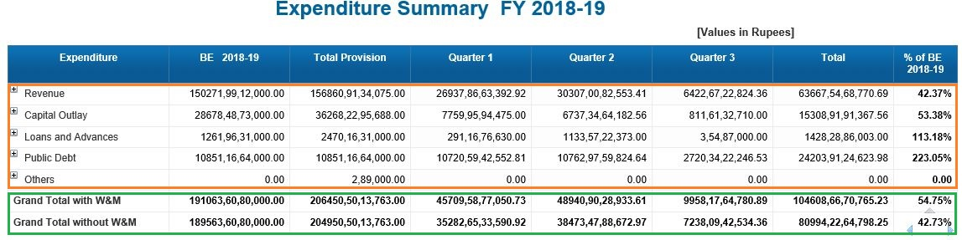

This Report displays Budget Estimation, Total Provision for the current fiscal year till date with Total & % of B.E for Current Fiscal Year under header.

The Rows within the Orange Box are derived from the Col-Formulas, and The Rows within the Green are derived from the Formulas under Grand Total with W&M and Grand Total without W&M as shown in the below Table.

List of Formulas used in Report Layer:

Column Names | Col Description | Colname formula | Col-Formula | Grand Total with W&M | Grand Total without W&M
Expenditure | Expenditure of the current  fiscal year | Expenditure | =[HOA_SUB_CAT_HIER] | NA | NA
BE-(Description) | Budget Estimate of  All departments | =Concatenation("BE ";  Right([Fiscal Year];5)) | =If ([CurrencyFlag] = 1) Then ([Budget Estimate])/10000000 Else If([CurrencyFlag] = 2) Then ([Budget Estimate])/100000 Else ([Budget Estimate]) | =If ([CurrencyFlag] = 1) Then ([Budget Estimate])/10000000 Else If([CurrencyFlag] = 2) Then ([Budget Estimate])/100000 Else ([Budget Estimate]) | =If ([CurrencyFlag] = 1) Then ([Budget Estimate]-[Budget Estimate] Where ([HOA_SUB_CAT_HIER]="Ways & Means Advance Payment"))/10000000 Else If([CurrencyFlag] = 2) Then ([Budget Estimate]-[Budget Estimate] Where ([HOA_SUB_CAT_HIER]="Ways & Means Advance Payment"))/100000 Else [Budget Estimate]-[Budget Estimate] Where ([HOA_SUB_CAT_HIER]="Ways & Means Advance Payment")
Total Provision | Amount of Budget estimate+Additional amount+Reappropriation amount-surrender amount | NA | =If ([CurrencyFlag] = 1) Then ([Total Provision]/10000000) ElseIf([CurrencyFlag] = 2) Then [Total Provision]/100000 Else [Total Provision] | =If ([CurrencyFlag] = 1) Then ([Total Provision]/10000000) ElseIf([CurrencyFlag] = 2) Then [Total Provision]/100000 Else [Total Provision] | =If ([CurrencyFlag] = 1) Then (([Total Provision] -[Total Provision] Where ([HOA_SUB_CAT_HIER]="Ways & Means Advance Payment") )/10000000) ElseIf([CurrencyFlag] = 2) Then (([Total Provision] -[Total Provision] Where ([HOA_SUB_CAT_HIER]="Ways & Means Advance Payment"))/100000) Else ([Total Provision] -[Total Provision] Where ([HOA_SUB_CAT_HIER]="Ways & Means Advance Payment"))
Quarters | Quarter wise | =If([BlockFilter]=[Previous FY]) Then [Quarter] Where ([Fiscal Year]=[Previous FY]) Else (If([Quarter] Where ([Fiscal Year]=[Current FY] Or [Fiscal Year]=[Previous FY]) = "Quarter 1" Or [Quarter] Where ([Fiscal Year]=[Current FY] Or [Fiscal Year]=[Previous FY]) = "Quarter 2" Or [Quarter] Where ([Fiscal Year]=[Current FY] Or [Fiscal Year]=[Previous FY]) = "Quarter 3" Or [Quarter] Where ([Fiscal Year]=[Current FY] Or [Fiscal Year]=[Previous FY]) = "Quarter 4") Then [Quarter] Where ([Fiscal Year]=[Current FY] Or [Fiscal Year]=[Previous FY]) Else ("Total "+Right([Quarter];7))) | =If (IsNull([Expenditure])) Then 0 Else (If ([CurrencyFlag] = 1) Then (Sum(If([BlockFilter]=[Previous FY]) Then Sum([Expenditure] Where ([Fiscal Year]=[Previous FY]); {Descendants([HOA_TYPE_HIER];1;Leaves)}) Else Sum([Expenditure] Where ([Fiscal Year]=[Current FY] Or [Fiscal Year]=[Previous FY]); {Descendants([HOA_TYPE_HIER];1;Leaves)})))/10000000 ElseIf([CurrencyFlag] = 2) Then Sum((If([BlockFilter]=[Previous FY]) Then Sum([Expenditure] Where ([Fiscal Year]=[Previous FY]); {Descendants([HOA_TYPE_HIER];1;Leaves)}) Else Sum([Expenditure] Where ([Fiscal Year]=[Current FY] Or [Fiscal Year]=[Previous FY]); {Descendants([HOA_TYPE_HIER];1;Leaves)})))/100000 Else Sum((If([BlockFilter]=[Previous FY]) Then Sum([Expenditure] Where ([Fiscal Year]=[Previous FY]); {Descendants([HOA_TYPE_HIER];1;Leaves)}) Else Sum([Expenditure] Where ([Fiscal Year]=[Current FY] Or [Fiscal Year]=[Previous FY]); {Descendants([HOA_TYPE_HIER];1;Leaves)})))) | =If (IsNull([Expenditure])) Then 0 Else (If ([CurrencyFlag] = 1) Then (Sum(If([BlockFilter]=[Previous FY]) Then Sum([Expenditure] Where ([Fiscal Year]=[Previous FY]); {Descendants([HOA_TYPE_HIER];1;After)}) Else Sum([Expenditure] Where ([Fiscal Year]=[Current FY] Or [Fiscal Year]=[Previous FY]); {Descendants([HOA_TYPE_HIER];1;After)})))/10000000 ElseIf([CurrencyFlag] = 2) Then Sum((If([BlockFilter]=[Previous FY]) Then Sum([Expenditure] Where ([Fiscal Year]=[Previous FY]); {Descendants([HOA_TYPE_HIER];1;After)}) Else Sum([Expenditure] Where ([Fiscal Year]=[Current FY] Or [Fiscal Year]=[Previous FY]); {Descendants([HOA_TYPE_HIER];1;After)})))/100000 Else Sum((If([BlockFilter]=[Previous FY]) Then Sum([Expenditure] Where ([Fiscal Year]=[Previous FY]); {Descendants([HOA_TYPE_HIER];1;After)}) Else Sum([Expenditure] Where ([Fiscal Year]=[Current FY] Or [Fiscal Year]=[Previous FY]); {Descendants([HOA_TYPE_HIER];1;After)})))) | =If (IsNull([Expenditure])) Then 0 Else (If ([CurrencyFlag] = 1) Then (Sum(If([BlockFilter]=[Previous FY]) Then Sum([Expenditure] Where ([Fiscal Year]=[Previous FY]); {Descendants([HOA_TYPE_HIER];1;After)}) Else Sum([Expenditure] Where ([Fiscal Year]=[Current FY] Or [Fiscal Year]=[Previous FY]); {Descendants([HOA_TYPE_HIER];1;After)}))- [Expenditure] Where ([Fiscal Year]=[Previous FY] And [HOA_TYPE_HIER]="Ways & Means Advance Payment"))/10000000 ElseIf([CurrencyFlag] = 2) Then (Sum((If([BlockFilter]=[Previous FY]) Then Sum([Expenditure] Where ([Fiscal Year]=[Previous FY]); {Descendants([HOA_TYPE_HIER];1;After)}) Else Sum([Expenditure] Where ([Fiscal Year]=[Current FY] Or [Fiscal Year]=[Previous FY]); {Descendants([HOA_TYPE_HIER];1;After)})))- [Expenditure] Where ([Fiscal Year]=[Previous FY] And [HOA_TYPE_HIER]="Ways & Means Advance Payment"))/100000 Else (Sum((If([BlockFilter]=[Previous FY]) Then Sum([Expenditure] Where ([Fiscal Year]=[Previous FY]); {Descendants([HOA_TYPE_HIER];1;After)}) Else Sum([Expenditure] Where ([Fiscal Year]=[Current FY] Or [Fiscal Year]=[Previous FY]); {Descendants([HOA_TYPE_HIER];1;After)}))) - [Expenditure] Where ([Fiscal Year]=[Previous FY] And [HOA_TYPE_HIER]="Ways & Means Advance Payment")))
Total | Total Budget of all Quarters | =If([Quarter] = "Quarter 1" Or [Quarter] = "Quarter 2" Or [Quarter] = "Quarter 3" Or [Quarter] = "Quarter 4") Then [Quarter] Else "Total"" | =If (IsNull([Expenditure])) Then 0 Else (If ([CurrencyFlag] = 1) Then [Expenditure]/10000000 ElseIf([CurrencyFlag] = 2) Then [Expenditure]/100000 Else [Expenditure]) | =If (IsNull([Expenditure])) Then 0 Else (If ([CurrencyFlag] = 1) Then [Expenditure]/10000000 ElseIf([CurrencyFlag] = 2) Then [Expenditure]/100000 Else [Expenditure]) | =If ([CurrencyFlag] = 1) Then ([Expenditure]-[Expenditure] Where ([HOA_SUB_CAT_HIER]="Ways & Means Advance Payment"))  /10000000 ElseIf([CurrencyFlag] = 2) Then ([Expenditure]-[Expenditure] Where ([HOA_SUB_CAT_HIER]="Ways & Means Advance Payment"))  /100000 Else ([Expenditure]-[Expenditure] Where ([HOA_SUB_CAT_HIER]="Ways & Means Advance Payment"))
% Of BE(Description) | Percentage of Budget estimate | =Concatenation("% of BE "+Char(13) + Char(10); Right([Fiscal Year];7)) | =If([Budget Estimate]=0) Then 0 Else ([Expenditure] Where([Quarter]=[Fiscal Year])/[Budget Estimate]) * 100 | =If([Budget Estimate]=0) Then 0 Else ([Expenditure] Where([Quarter]=[Fiscal Year])/[Budget Estimate]) * 100 | =If([Budget Estimate]-[Budget Estimate] Where ([HOA_SUB_CAT_HIER]="Ways & Means Advance Payment") =0) Then 0 Else ([Expenditure]-[Expenditure] Where ([HOA_SUB_CAT_HIER]="Ways & Means Advance Payment")) Where([Quarter]=[Fiscal Year])/([Budget Estimate]-[Budget Estimate] Where ([HOA_SUB_CAT_HIER]="Ways & Means Advance Payment")) * 100

Expenditure Monthly Comparison Report Level Calculations and Formulas used:

Screen shots with compare Radio button:
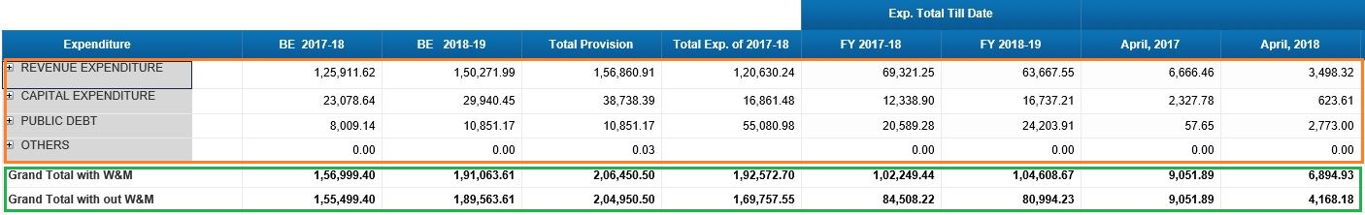

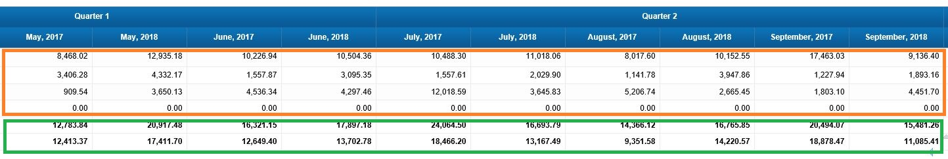

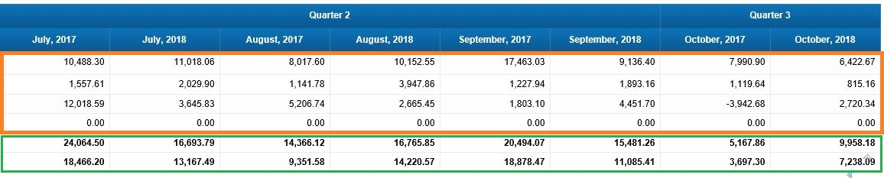

Screen shot with no compare Radio button:

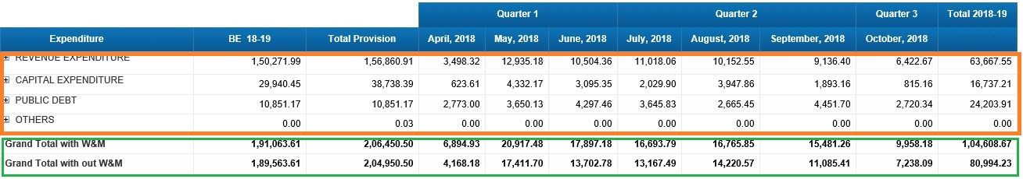

This Report displays Budget Estimation, Total Provision ,Total expenditure of previous year and monthly wise comparision from the past year to till date as header.
The Rows within the Orange Box are derived from the Col-Formulas, and the Rows with the Green are derived from the Formulas under Grand Total with W&M and Grand Total without W&M as shown in the below Table.

List of Formulas used in Report Layer:

Column Names | Col Description | Colname formula |  | Col-Formula | Grand Total with W&M | Grand Total without W&M
BE (2017-2018) | Budget Estimate ofall departments | =Concatenation("BE "; Right([Previous FY];7)) |  | =If(IsNull([Budget Estimate] Where ([Fiscal Year]=[Previous FY]))) Then 0 Else (If([CurrencyFlag] = 1) Then Sum([Budget Estimate] Where ([Fiscal Year]=[Previous FY]); {Descendants([HOA_TYPE_HIER];1;Leaves)})/10000000 ElseIf([CurrencyFlag] = 2) Then Sum([Budget Estimate] Where ([Fiscal Year]=[Previous FY]); {Descendants([HOA_TYPE_HIER];1;Leaves)})/100000 Else Sum([Budget Estimate] Where ([Fiscal Year]=[Previous FY]); {Descendants([HOA_TYPE_HIER];1;Leaves)})) | =If(IsNull([Budget Estimate])) Then 0 Else (If([CurrencyFlag] = 1) Then Sum(Sum([Budget Estimate] Where ([Fiscal Year]=[Previous FY]); {Descendants([HOA_TYPE_HIER];1;After)}))/10000000 ElseIf([CurrencyFlag] = 2) Then Sum(Sum([Budget Estimate] Where ([Fiscal Year]=[Previous FY]); {Descendants([HOA_TYPE_HIER];1;After)}))/100000 Else Sum(Sum([Budget Estimate] Where ([Fiscal Year]=[Previous FY]); {Descendants([HOA_TYPE_HIER];1;After)}))) | =If(IsNull([Budget Estimate])) Then 0 Else (If([CurrencyFlag] = 1) Then (Sum(Sum([Budget Estimate] Where ([Fiscal Year]=[Previous FY]); {Descendants([HOA_TYPE_HIER];1;After)}))- [Budget Estimate] Where ([Fiscal Year]=[Previous FY] And [HOA_TYPE_HIER]="Ways & Means Advance Payment"))/10000000 ElseIf([CurrencyFlag] = 2) Then (Sum(Sum([Budget Estimate] Where ([Fiscal Year]=[Previous FY]); {Descendants([HOA_TYPE_HIER];1;After)}))- [Budget Estimate] Where ([Fiscal Year]=[Previous FY] And [HOA_TYPE_HIER]="Ways & Means Advance Payment"))/100000 Else (Sum(Sum([Budget Estimate] Where ([Fiscal Year]=[Previous FY]); {Descendants([HOA_TYPE_HIER];1;After)})))-[Budget Estimate] Where ([Fiscal Year]=[Previous FY] And [HOA_TYPE_HIER]="Ways & Means Advance Payment"))
BE(2018-2019) | Budget Estimate ofall departments | =Concatenation("BE "; Right([BlockFilter];8)) |  | =If(IsNull([Budget Estimate] Where ([Fiscal Year]=[BlockFilter]))) Then 0 Else (If([CurrencyFlag] = 1) Then Sum([Budget Estimate] Where ([Fiscal Year]=[BlockFilter]); {Descendants([HOA_TYPE_HIER];1;Leaves)})/10000000 ElseIf([CurrencyFlag] = 2) Then Sum([Budget Estimate] Where ([Fiscal Year]=[BlockFilter]); {Descendants([HOA_TYPE_HIER];1;Leaves)})/100000 Else Sum([Budget Estimate] Where ([Fiscal Year]=[BlockFilter]); {Descendants([HOA_TYPE_HIER];1;Leaves)})) | =If(IsNull([Budget Estimate])) Then 0 Else (If([CurrencyFlag] = 1) Then Sum(Sum([Budget Estimate] Where ([Fiscal Year]=[BlockFilter]); {Descendants([HOA_TYPE_HIER];1;After)}))/10000000 ElseIf([CurrencyFlag] = 2) Then Sum(Sum([Budget Estimate] Where ([Fiscal Year]=[BlockFilter]); {Descendants([HOA_TYPE_HIER];1;After)}))/100000 Else Sum(Sum([Budget Estimate] Where ([Fiscal Year]=[BlockFilter]); {Descendants([HOA_TYPE_HIER];1;After)}))) | =If(IsNull([Budget Estimate])) Then 0 Else (If([CurrencyFlag] = 1) Then (Sum(Sum([Budget Estimate] Where ([Fiscal Year]=[BlockFilter]); {Descendants([HOA_TYPE_HIER];1;After)}))- [Budget Estimate] Where ([Fiscal Year]=[BlockFilter] And [HOA_TYPE_HIER]="Ways & Means Advance Payment"))/10000000 ElseIf([CurrencyFlag] = 2) Then (Sum(Sum([Budget Estimate] Where ([Fiscal Year]=[BlockFilter]); {Descendants([HOA_TYPE_HIER];1;After)}))- [Budget Estimate] Where ([Fiscal Year]=[BlockFilter] And [HOA_TYPE_HIER]="Ways & Means Advance Payment"))/100000 Else (Sum(Sum([Budget Estimate] Where ([Fiscal Year]=[BlockFilter]); {Descendants([HOA_TYPE_HIER];1;After)})))-[Budget Estimate] Where ([Fiscal Year]=[BlockFilter] And [HOA_TYPE_HIER]="Ways & Means Advance Payment"))
Total Provision | Amount of Budget estimate+Additional amount+Reappropriation amount-surrender amount | NA |  | =If(IsNull([Total Provision] Where ([Fiscal Year]=[BlockFilter]))) Then 0 Else (If ([CurrencyFlag] = 1) Then Sum([Total Provision] Where ([Fiscal Year]=[BlockFilter]); {Descendants([HOA_TYPE_HIER];1;Leaves)})/10000000 ElseIf([CurrencyFlag] = 2) Then Sum([Total Provision] Where ([Fiscal Year]=[BlockFilter]); {Descendants([HOA_TYPE_HIER];1;Leaves)})/100000 Else Sum([Total Provision] Where ([Fiscal Year]=[BlockFilter]); {Descendants([HOA_TYPE_HIER];1;Leaves)})) | =If(IsNull([Total Provision])) Then 0 Else (If([CurrencyFlag] = 1) Then Sum(Sum([Total Provision] Where ([Fiscal Year]=[BlockFilter]); {Descendants([HOA_TYPE_HIER];1;After)}))/10000000 ElseIf([CurrencyFlag] = 2) Then Sum(Sum([Total Provision] Where ([Fiscal Year]=[BlockFilter]); {Descendants([HOA_TYPE_HIER];1;After)}))/100000 Else Sum(Sum([Total Provision] Where ([Fiscal Year]=[BlockFilter]); {Descendants([HOA_TYPE_HIER];1;After)}))) | =If(IsNull([Total Provision])) Then 0 Else (If([CurrencyFlag] = 1) Then (Sum(Sum([Total Provision] Where ([Fiscal Year]=[BlockFilter]); {Descendants([HOA_TYPE_HIER];1;After)}))- [Total Provision] Where ([Fiscal Year]=[BlockFilter] And [HOA_TYPE_HIER]="Ways & Means Advance Payment"))/10000000 ElseIf([CurrencyFlag] = 2) Then (Sum(Sum([Total Provision] Where ([Fiscal Year]=[BlockFilter]); {Descendants([HOA_TYPE_HIER];1;After)}))- [Total Provision] Where ([Fiscal Year]=[BlockFilter] And [HOA_TYPE_HIER]="Ways & Means Advance Payment"))/100000 Else (Sum(Sum([Total Provision] Where ([Fiscal Year]=[BlockFilter]); {Descendants([HOA_TYPE_HIER];1;After)})))-[Total Provision] Where ([Fiscal Year]=[BlockFilter] And [HOA_TYPE_HIER]="Ways & Means Advance Payment"))
Quarter1,2,3, &Total exp. Till date | Total exp.of all quarters to till date | =If([BlockFilter]=[Previous FY]) Then [Quarter] Where ([Fiscal Year]=[Previous FY]) Else (If([Quarter] Where ([Fiscal Year]=[Current FY] Or [Fiscal Year]=[Previous FY]) = "Quarter 1" Or [Quarter] Where ([Fiscal Year]=[Current FY] Or [Fiscal Year]=[Previous FY]) = "Quarter 2" Or [Quarter] Where ([Fiscal Year]=[Current FY] Or [Fiscal Year]=[Previous FY]) = "Quarter 3" Or [Quarter] Where ([Fiscal Year]=[Current FY] Or [Fiscal Year]=[Previous FY]) = "Quarter 4") Then [Quarter] Where ([Fiscal Year]=[Current FY] Or [Fiscal Year]=[Previous FY]) Else "Exp. Total Till Date") | =If ([QuerySubCat].[Month] InList("April";"May";"June";"July";"August";"September";"October"; "November"; "December")) Then Concatenation([Variables].[Month]+", "; Substr([Fiscal Year]; 4;4)) ElseIf ([QuerySubCat].[Month] InList("January";"February";"March")) Then Concatenation([Variables].[Month]+", "; FormatNumber ((ToNumber(Substr([Fiscal Year]; 4;4))+1);"####")) ElseIf ([QuerySubCat].[Month] InList("FY 2017-18")) Then "FY 2017-18" ElseIf ([QuerySubCat].[Month] InList("FY 2018-19")) Then "FY 2018-19" | =If (IsNull([Expenditure])) Then 0 Else (If ([CurrencyFlag] = 1) Then (Sum(If([BlockFilter]=[Previous FY]) Then Sum([Expenditure] Where ([Fiscal Year]=[Previous FY]); {Descendants([HOA_TYPE_HIER];1;Leaves)}) Else Sum([Expenditure] Where ([Fiscal Year]=[Current FY] Or [Fiscal Year]=[Previous FY]); {Descendants([HOA_TYPE_HIER];1;Leaves)})))/10000000 ElseIf([CurrencyFlag] = 2) Then Sum((If([BlockFilter]=[Previous FY]) Then Sum([Expenditure] Where ([Fiscal Year]=[Previous FY]); {Descendants([HOA_TYPE_HIER];1;Leaves)}) Else Sum([Expenditure] Where ([Fiscal Year]=[Current FY] Or [Fiscal Year]=[Previous FY]); {Descendants([HOA_TYPE_HIER];1;Leaves)})))/100000 Else Sum((If([BlockFilter]=[Previous FY]) Then Sum([Expenditure] Where ([Fiscal Year]=[Previous FY]); {Descendants([HOA_TYPE_HIER];1;Leaves)}) Else Sum([Expenditure] Where ([Fiscal Year]=[Current FY] Or [Fiscal Year]=[Previous FY]); {Descendants([HOA_TYPE_HIER];1;Leaves)})))) | = =If (IsNull([Expenditure])) Then 0 Else (If ([CurrencyFlag] = 1) Then (Sum(If([BlockFilter]=[Previous FY]) Then Sum([Expenditure] Where ([Fiscal Year]=[Previous FY]); {Descendants([HOA_TYPE_HIER];1;After)}) Else Sum([Expenditure] Where ([Fiscal Year]=[Current FY] Or [Fiscal Year]=[Previous FY]); {Descendants([HOA_TYPE_HIER];1;After)})))/10000000 ElseIf([CurrencyFlag] = 2) Then Sum((If([BlockFilter]=[Previous FY]) Then Sum([Expenditure] Where ([Fiscal Year]=[Previous FY]); {Descendants([HOA_TYPE_HIER];1;After)}) Else Sum([Expenditure] Where ([Fiscal Year]=[Current FY] Or [Fiscal Year]=[Previous FY]); {Descendants([HOA_TYPE_HIER];1;After)})))/100000 Else Sum((If([BlockFilter]=[Previous FY]) Then Sum([Expenditure] Where ([Fiscal Year]=[Previous FY]); {Descendants([HOA_TYPE_HIER];1;After)}) Else Sum([Expenditure] Where ([Fiscal Year]=[Current FY] Or [Fiscal Year]=[Previous FY]); {Descendants([HOA_TYPE_HIER];1;After)})))) | =If (IsNull([Expenditure])) Then 0 Else (If ([CurrencyFlag] = 1) Then (Sum(If([BlockFilter]=[Previous FY]) Then Sum([Expenditure] Where ([Fiscal Year]=[Current FY]); {Descendants([HOA_TYPE_HIER];1;After)}) Else Sum([Expenditure] Where ([Fiscal Year]=[Current FY] Or [Fiscal Year]=[Previous FY]); {Descendants([HOA_TYPE_HIER];1;After)}))- [Expenditure] Where (([Fiscal Year]=[Current FY] Or [Fiscal Year]=[Previous FY]) And [HOA_TYPE_HIER]="Ways & Means Advance Payment"))/10000000 ElseIf([CurrencyFlag] = 2) Then (Sum((If([BlockFilter]=[Previous FY]) Then Sum([Expenditure] Where ([Fiscal Year]=[Previous FY]); {Descendants([HOA_TYPE_HIER];1;After)}) Else Sum([Expenditure] Where ([Fiscal Year]=[Current FY] Or [Fiscal Year]=[Previous FY]); {Descendants([HOA_TYPE_HIER];1;After)})))- [Expenditure] Where (([Fiscal Year]=[Current FY] Or [Fiscal Year]=[Previous FY]) And [HOA_TYPE_HIER]="Ways & Means Advance Payment"))/100000 Else (Sum((If([BlockFilter]=[Previous FY]) Then Sum([Expenditure] Where ([Fiscal Year]=[Previous FY]); {Descendants([HOA_TYPE_HIER];1;After)}) Else Sum([Expenditure] Where ([Fiscal Year]=[Current FY] Or [Fiscal Year]=[Previous FY]); {Descendants([HOA_TYPE_HIER];1;After)}))) - [Expenditure] Where (([Fiscal Year]=[Current FY] Or [Fiscal Year]=[Previous FY]) And [HOA_TYPE_HIER]="Ways & Means Advance Payment")))
Total Exp. of 2017-18 | Total expenditure of the year 2017-2018 | NA |  | =If ([CurrencyFlag] = 1) Then ((([Expenditure (Total)] Where (([Fiscal Year]="FY 2017-18") And Not([QuerySubCat].[Month] InList("FY 2016-17";"FY 2017-18";"FY 2018-19"))))/2))/10000000 Else If([CurrencyFlag] = 2) Then (([Expenditure (Total)] Where (([Fiscal Year]="FY 2017-18") And Not([QuerySubCat].[Month] InList("FY 2016-17";"FY 2017-18";"FY 2018-19")))/2))/100000 Else (([Expenditure (Total)] Where (([Fiscal Year]="FY 2017-18") And Not([QuerySubCat].[Month] InList("FY 2016-17";"FY 2017-18";"FY 2018-19")))/2)) | =If ([CurrencyFlag] = 1) Then ((([Expenditure (Total)] Where (([Fiscal Year]="FY 2017-18") And Not([QuerySubCat].[Month] InList("FY 2016-17";"FY 2017-18";"FY 2018-19"))))/2))/10000000 Else If([CurrencyFlag] = 2) Then ((([Expenditure (Total)] Where (([Fiscal Year]="FY 2017-18") And Not([QuerySubCat].[Month] InList("FY 2016-17";"FY 2017-18";"FY 2018-19"))))/2))/100000 Else ((([Expenditure (Total)] Where (([Fiscal Year]="FY 2017-18") And Not([QuerySubCat].[Month] InList("FY 2016-17";"FY 2017-18";"FY 2018-19"))))/2)) | =If ([CurrencyFlag] = 1) Then (([Expenditure (Total)] Where (([Fiscal Year]="FY 2017-18") And Not([QuerySubCat].[Month] InList("FY 2016-17";"FY 2017-18";"FY 2018-19"))))/2-([Expenditure (Total)] Where (([Fiscal Year]="FY 2017-18") And Not([QuerySubCat].[Month] InList("FY 2016-17";"FY 2017-18";"FY 2018-19")) And [HOA_TYPE_HIER]="Ways & Means Advance Payment")/2))/10000000 Else If([CurrencyFlag] = 2) Then (([Expenditure (Total)] Where (([Fiscal Year]="FY 2017-18") And Not([QuerySubCat].[Month] InList("FY 2016-17";"FY 2017-18";"FY 2018-19"))))/2-([Expenditure (Total)] Where (([Fiscal Year]="FY 2017-18") And Not([QuerySubCat].[Month] InList("FY 2016-17";"FY 2017-18";"FY 2018-19")) And [HOA_TYPE_HIER]="Ways & Means Advance Payment")/2))/100000 Else (([Expenditure (Total)] Where (([Fiscal Year]="FY 2017-18") And Not([QuerySubCat].[Month] InList("FY 2016-17";"FY 2017-18";"FY 2018-19"))))/2-([Expenditure (Total)] Where (([Fiscal Year]="FY 2017-18") And Not([QuerySubCat].[Month] InList("FY 2016-17";"FY 2017-18";"FY 2018-19")) And [HOA_TYPE_HIER]="Ways & Means Advance Payment")/2))

Expenditure HOA Report Level Calculations and Formulas used:

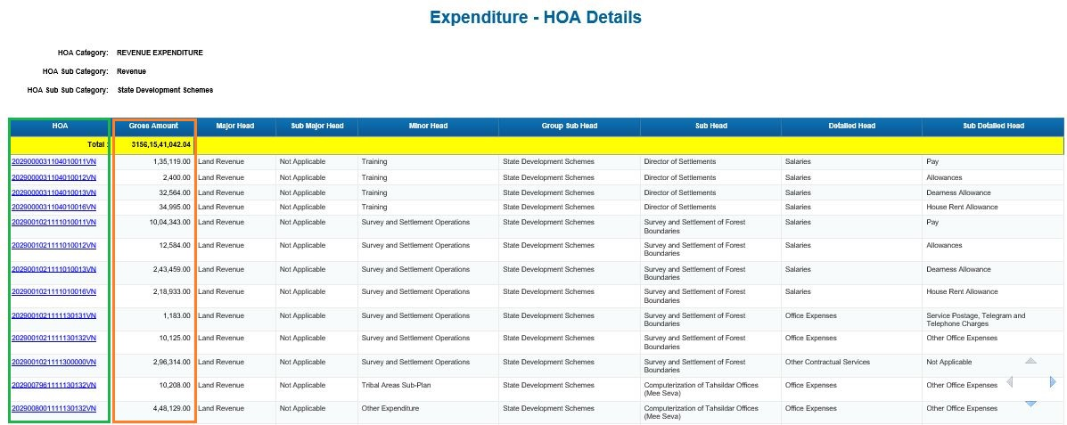

This Report displays HOA, Gross Amount, Major Head, Sub Major Head, Minor Head, Group Sub Head, Sub Head, Detailed Head, Sub Detailed Head of particular categories and sub categories of HOA as header.
Here Gross Amount is displayed in orange color box as per the selected HOA Category which is in green color box, HOA with Sub Category Wise and Sub Sub Category wise is displayed.
List of Formulas used in Report Layer:

Column Names | Col Description | Colname formula | Col-Formula | Total
HOA | Head of accounts which are the main units of accounts classification under the various sectors, keeping in view the existing plan and accounts classification, the nature and magnitude of expenditure on plan and non-plan account. | =NameOf([HOA]) | ="<a href=\"../../opendoc/openDocument.jsp?iDocID=Fk31zlspjwEAj2sAAACHkLQAAFBWlxfh&sIDType=CUID&sType=wid&lang=EN_US&sRefresh=N&lsSpsHana%20Variable%20IP_HOA_SUB_SUB_CAT="+URLEncode(""+[IP_HOA_SUB_SUB_CAT])+"&lsSpsHana%20Variable%20IP_HOA_CAT="+URLEncode(""+[IP_HOA_CAT])+"&lsSpsHana%20Variable%20IP_HOA_SUB_CAT="+URLEncode(""+[IP_HOA_SUB_CAT])+"&lsSpsHana%20Variable%20IP_FISCAL_YEAR="+URLEncode(""+[IP_FISCAL_YEAR])+"&lsMpmHana%20Variable%20IP_HOA="+URLEncode(""+[HOA])+"&lsSpsHana%20Variable%20IP_FROM_DATE="+URLEncode(""+Min([Posting Date]))+"&lsSpsHana%20Variable%20IP_TO_DATE="+URLEncode(""+Max([Posting Date]))+"\" title=\"\" target=\"_blank\" nav=\"doc\">"+[HOA]+"</a>" | =If ([CurrencyFlag] = 1) Then ([Expenditure]/10000000) ElseIf([CurrencyFlag] = 2) Then ([Expenditure])/100000 Else [Expenditure]
Gross Amount | Gross Amount of the Partciular HOA with respective Particular Departments | Gross Amount | =If ([CurrencyFlag] = 1) Then ([Expenditure]/10000000) ElseIf([CurrencyFlag] = 2) Then ([Expenditure])/100000 Else [Expenditure]
Major Head | Recording and classifying the receipts and disbursements relating to the functions of the Government | =NameOf([Major Head]) | =If ([CurrencyFlag] = 1) Then ([Expenditure]/10000000) ElseIf([CurrencyFlag] = 2) Then ([Expenditure])/100000 Else [Expenditure]
Sub Major Head | Sub major heads are opened under a major head to record those transactions which are of a distinct nature and are of sufficient importance to be recorded exclusively | =NameOf([Sub Major Head]) | =[Sub Major Head]
Minor Head | Minor head means a head subordinate to a Major head or SubMajor head representing a specific programme | =NameOf([Minor Head]) | =[Minor Head]
Group SubHead | In between the Programme Minor head and Sub head representing a similar group of schemes which are implemented under a separate funding pattern | =NameOf([Group Sub Head]) | =[Group Sub Head]
SubHead | head subordinate to a minor head. It indicates schemes for Plan Programmes or administrative set-up in the case of non-plan expenditure. | =NameOf([Sub Head]) | =[Sub Head]
DetailedHead | is the primary unit of appropriation. It exhibits expenditure under basic items like Salaries, Travel Expenses, Office Expenses etc. | =NameOf([Detailed Head]) | =[Detailed Head]
Sub DetailedHead | denote break-up of detailed heads or object classification, wherever necessary, and possib | =NameOf([Sub Detailed Head]) | =[Sub Detailed Head]

Expenditure Quarterly Comparison Report Level Calculations and Formulas used:

This Report displays Budget Estimation, Total Provision, Quarter Wise Expenditure and Total Expenditure of present year to till date as header. The Rows within the Orange Box are derived from the Col-Formulas, and the Rows within the Green are derived from the Formulas under Grand Total with W&M and Grand Total without W&M as shown in the below Table.

List of Formulas used in Report Layer.

Column Names |  | Col Description | Colname formula |  | Col-Formula | Grand Total with W&M | Grand Total without W&M
Quarter 1  Growth % |  | Expenditure  Growth percentage of quarter 1 | NA |  | =If([Expenditure]=0) Then "NA" Else (([Expenditure] Where ([Fiscal Year]=[Current FY] And [Quarter]= "Quarter 1"))/([Expenditure] Where ([Fiscal Year]=[Previous FY] And [Quarter]= "Quarter 1"))*100)-100 + "%" | =If([Expenditure]=0) Then "NA" Else (([Expenditure] Where ([Fiscal Year]=[Current FY] And [Quarter]= "Quarter 3"))/([Expenditure] Where ([Fiscal Year]=[Previous FY] And [Quarter]= "Quarter 3"))*100)-100 + "%" | =If([Expenditure]=0) Then "NA" Else (([Expenditure] Where ([Fiscal Year]=[Current FY] And [Quarter]= "Quarter 3"))/([Expenditure] Where ([Fiscal Year]=[Previous FY] And [Quarter]= "Quarter 3"))*100)-100 + "%"
Quarter 2  Growth % |  | Expenditure  Growth percentage of quarter 2 | NA |  | =If([Expenditure]=0) Then "NA" Else (([Expenditure] Where ([Fiscal Year]=[Current FY] And [Quarter]= "Quarter 2"))/([Expenditure] Where ([Fiscal Year]=[Previous FY] And [Quarter]= "Quarter 2"))*100)-100 + "%" | =If([Expenditure]=0) Then "NA" Else (([Expenditure] Where ([Fiscal Year]=[Current FY] And [Quarter]= "Quarter 3"))/([Expenditure] Where ([Fiscal Year]=[Previous FY] And [Quarter]= "Quarter 3"))*100)-100 + "%" | =(([Grand Without W&M] Where ([Fiscal Year]=[Current FY] And [Quarter]= "Quarter 2"))/([Grand Without W&M] Where ([Fiscal Year]=[Previous FY] And [Quarter]= "Quarter 2"))*100)-100 + "%"
Quarter 3  Growth % |  | Expenditure  Growth percentage of quarter 3 | NA |  | =If([Expenditure]=0) Then "NA" Else (([Expenditure] Where ([Fiscal Year]=[Current FY] And [Quarter]= "Quarter 3"))/([Expenditure] Where ([Fiscal Year]=[Previous FY] And [Quarter]= "Quarter 3"))*100)-100 + "%" | =(([Grand W&M] Where ([Fiscal Year]=[Current FY] And [Quarter]= "Quarter 3"))/([Grand W&M] Where ([Fiscal Year]=[Previous FY] And [Quarter]= "Quarter 3"))*100)-100 + "%" | =(([Grand Without W&M] Where ([Fiscal Year]=[Current FY] And [Quarter]= "Quarter 3"))/([Grand Without W&M] Where ([Fiscal Year]=[Previous FY] And [Quarter]= "Quarter 3"))*100)-100 + "%"
Current Year Growth % |  | Growth Percentage of current Fiscal Year | NA |  | =If([Expenditure]=0) Then "NA" Else (([Expenditure] Where ([Fiscal Year]=[Current FY] And [Quarter]= "Quarter 3"))/([Expenditure] Where ([Fiscal Year]=[Previous FY] And [Quarter]= "Quarter 3"))*100)-100 + "%" | =If([Expenditure]=0) Then "NA" Else (([Expenditure] Where ([Fiscal Year]="FY 2018-19" And [Quarter]= "FY 2018-19"))/[Expenditure] Where ([Fiscal Year]="FY 2017-18" And [Quarter]= "FY 2017-18")*100-100) +"%" | =(([Expenditure] Where ([Fiscal Year]="FY 2018-19" And [Quarter]= "FY 2018-19")-[Expenditure] Where ([Fiscal Year]="FY 2018-19" And [Quarter]= "FY 2018-19" And [HOA_SUB_CAT_HIER]="Ways & Means Advance Payment"))/([Expenditure] Where ([Fiscal Year]="FY 2017-18" And [Quarter]= "FY 2017-18")-[Expenditure] Where ([Fiscal Year]="FY 2017-18" And [Quarter]= "FY 2017-18" And [HOA_SUB_CAT_HIER]="Ways & Means Advance Payment"))*100-100) +"%"
EXP.  TOTAL TILL DATE | FY 2017-2018 | Total Expenditure of previous Year and present year | =If([BlockFilter]=[Previous FY]) Then [Quarter] Where ([Fiscal Year]=[Previous FY]) Else (If([Quarter] Where ([Fiscal Year]=[Current FY] Or [Fiscal Year]=[Previous FY]) = "Quarter 1" Or [Quarter] Where ([Fiscal Year]=[Current FY] Or [Fiscal Year]=[Previous FY]) = "Quarter 2" Or [Quarter] Where ([Fiscal Year]=[Current FY] Or [Fiscal Year]=[Previous FY]) = "Quarter 3" Or [Quarter] Where ([Fiscal Year]=[Current FY] Or [Fiscal Year]=[Previous FY]) = "Quarter 4") Then [Quarter] Where ([Fiscal Year]=[Current FY] Or [Fiscal Year]=[Previous FY]) Else "Exp. Total Till Date") | =If([BlockFilter]=[Previous FY]) Then [Fiscal Year] Where ([Fiscal Year]=[Previous FY])Else [Fiscal Year] Where ([Fiscal Year]=[Current FY] Or [Fiscal Year]=[Previous FY]) | =If ([CurrencyFlag] = 1) Then ([Expenditure]-[Expenditure] Where (([Fiscal Year]=[Current FY] Or [Fiscal Year]=[Previous FY]) And [HOA_SUB_CAT_HIER]="Ways & Means Advance Payment"))/10000000 ElseIf([CurrencyFlag] = 2) Then ([Expenditure]-[Expenditure] Where (([Fiscal Year]=[Current FY] Or [Fiscal Year]=[Previous FY]) And [HOA_SUB_CAT_HIER]="Ways & Means Advance Payment"))/100000 Else ([Expenditure]-[Expenditure] Where (([Fiscal Year]=[Current FY] Or [Fiscal Year]=[Previous FY]) And [HOA_SUB_CAT_HIER]="Ways & Means Advance Payment")) | =If (IsNull([Expenditure])) Then 0 Else (If ([CurrencyFlag] = 1) Then [Expenditure]/10000000 ElseIf([CurrencyFlag] = 2) Then [Expenditure]/100000 Else [Expenditure]) | =If ([CurrencyFlag] = 1) Then ([Expenditure]-[Expenditure] Where (([Fiscal Year]=[Current FY] Or [Fiscal Year]=[Previous FY]) And [HOA_SUB_CAT_HIER]="Ways & Means Advance Payment"))/10000000 ElseIf([CurrencyFlag] = 2) Then ([Expenditure]-[Expenditure] Where (([Fiscal Year]=[Current FY] Or [Fiscal Year]=[Previous FY]) And [HOA_SUB_CAT_HIER]="Ways & Means Advance Payment"))/100000 Else ([Expenditure]-[Expenditure] Where (([Fiscal Year]=[Current FY] Or [Fiscal Year]=[Previous FY]) And [HOA_SUB_CAT_HIER]="Ways & Means Advance Payment"))
EXP.  TOTAL TILL DATE | FY 2018-2019
Quarter1 | FY 2017-2018 | Quarter1  Expenditure of previous Year and present year | =If([BlockFilter]=[Previous FY]) Then [Quarter] Where ([Fiscal Year]=[Previous FY]) Else (If([Quarter] Where ([Fiscal Year]=[Current FY] Or [Fiscal Year]=[Previous FY]) = "Quarter 1" Or [Quarter] Where ([Fiscal Year]=[Current FY] Or [Fiscal Year]=[Previous FY]) = "Quarter 2" Or [Quarter] Where ([Fiscal Year]=[Current FY] Or [Fiscal Year]=[Previous FY]) = "Quarter 3" Or [Quarter] Where ([Fiscal Year]=[Current FY] Or [Fiscal Year]=[Previous FY]) = "Quarter 4") Then [Quarter] Where ([Fiscal Year]=[Current FY] Or [Fiscal Year]=[Previous FY]) Else "Exp. Total Till Date") | =If([BlockFilter]=[Previous FY]) Then [Fiscal Year] Where ([Fiscal Year]=[Previous FY])Else [Fiscal Year] Where ([Fiscal Year]=[Current FY] Or [Fiscal Year]=[Previous FY]) | =If (IsNull([Expenditure])) Then 0 Else (If ([CurrencyFlag] = 1) Then [Expenditure]/10000000 ElseIf([CurrencyFlag] = 2) Then [Expenditure]/100000 Else [Expenditure]) | =If (IsNull([Expenditure])) Then 0 Else (If ([CurrencyFlag] = 1) Then [Expenditure]/10000000 ElseIf([CurrencyFlag] = 2) Then [Expenditure]/100000 Else [Expenditure]) | =If ([CurrencyFlag] = 1) Then ([Expenditure]-[Expenditure] Where (([Fiscal Year]=[Current FY] Or [Fiscal Year]=[Previous FY]) And [HOA_SUB_CAT_HIER]="Ways & Means Advance Payment"))/10000000 ElseIf([CurrencyFlag] = 2) Then ([Expenditure]-[Expenditure] Where (([Fiscal Year]=[Current FY] Or [Fiscal Year]=[Previous FY]) And [HOA_SUB_CAT_HIER]="Ways & Means Advance Payment"))/100000 Else ([Expenditure]-[Expenditure] Where (([Fiscal Year]=[Current FY] Or [Fiscal Year]=[Previous FY]) And [HOA_SUB_CAT_HIER]="Ways & Means Advance Payment"))
Quarter1 | FY 2018-2019
Quarter2 | FY 2017-2018 | Quarter2  Expenditure of previous Year and present year | =If([BlockFilter]=[Previous FY]) Then [Quarter] Where ([Fiscal Year]=[Previous FY]) Else (If([Quarter] Where ([Fiscal Year]=[Current FY] Or [Fiscal Year]=[Previous FY]) = "Quarter 1" Or [Quarter] Where ([Fiscal Year]=[Current FY] Or [Fiscal Year]=[Previous FY]) = "Quarter 2" Or [Quarter] Where ([Fiscal Year]=[Current FY] Or [Fiscal Year]=[Previous FY]) = "Quarter 3" Or [Quarter] Where ([Fiscal Year]=[Current FY] Or [Fiscal Year]=[Previous FY]) = "Quarter 4") Then [Quarter] Where ([Fiscal Year]=[Current FY] Or [Fiscal Year]=[Previous FY]) Else "Exp. Total Till Date") | =If([BlockFilter]=[Previous FY]) Then [Fiscal Year] Where ([Fiscal Year]=[Previous FY])Else [Fiscal Year] Where ([Fiscal Year]=[Current FY] Or [Fiscal Year]=[Previous FY]) | =If (IsNull([Expenditure])) Then 0 Else (If ([CurrencyFlag] = 1) Then [Expenditure]/10000000 ElseIf([CurrencyFlag] = 2) Then [Expenditure]/100000 Else [Expenditure]) | =If (IsNull([Expenditure])) Then 0 Else (If ([CurrencyFlag] = 1) Then [Expenditure]/10000000 ElseIf([CurrencyFlag] = 2) Then [Expenditure]/100000 Else [Expenditure]) | =If ([CurrencyFlag] = 1) Then ([Expenditure]-[Expenditure] Where (([Fiscal Year]=[Current FY] Or [Fiscal Year]=[Previous FY]) And [HOA_SUB_CAT_HIER]="Ways & Means Advance Payment"))/10000000 ElseIf([CurrencyFlag] = 2) Then ([Expenditure]-[Expenditure] Where (([Fiscal Year]=[Current FY] Or [Fiscal Year]=[Previous FY]) And [HOA_SUB_CAT_HIER]="Ways & Means Advance Payment"))/100000 Else ([Expenditure]-[Expenditure] Where (([Fiscal Year]=[Current FY] Or [Fiscal Year]=[Previous FY]) And [HOA_SUB_CAT_HIER]="Ways & Means Advance Payment"))
Quarter2 | FY 2018-2019
Quarter3 | FY 2017-2018 | Quarter3  Expenditure of previous Year and present year | =If([BlockFilter]=[Previous FY]) Then [Quarter] Where ([Fiscal Year]=[Previous FY]) Else (If([Quarter] Where ([Fiscal Year]=[Current FY] Or [Fiscal Year]=[Previous FY]) = "Quarter 1" Or [Quarter] Where ([Fiscal Year]=[Current FY] Or [Fiscal Year]=[Previous FY]) = "Quarter 2" Or [Quarter] Where ([Fiscal Year]=[Current FY] Or [Fiscal Year]=[Previous FY]) = "Quarter 3" Or [Quarter] Where ([Fiscal Year]=[Current FY] Or [Fiscal Year]=[Previous FY]) = "Quarter 4") Then [Quarter] Where ([Fiscal Year]=[Current FY] Or [Fiscal Year]=[Previous FY]) Else "Exp. Total Till Date") | =If([BlockFilter]=[Previous FY]) Then [Fiscal Year] Where ([Fiscal Year]=[Previous FY])Else [Fiscal Year] Where ([Fiscal Year]=[Current FY] Or [Fiscal Year]=[Previous FY]) | =If (IsNull([Expenditure])) Then 0 Else (If ([CurrencyFlag] = 1) Then [Expenditure]/10000000 ElseIf([CurrencyFlag] = 2) Then [Expenditure]/100000 Else [Expenditure]) | =If (IsNull([Expenditure])) Then 0 Else (If ([CurrencyFlag] = 1) Then [Expenditure]/10000000 ElseIf([CurrencyFlag] = 2) Then [Expenditure]/100000 Else [Expenditure]) | =If ([CurrencyFlag] = 1) Then ([Expenditure]-[Expenditure] Where (([Fiscal Year]=[Current FY] Or [Fiscal Year]=[Previous FY]) And [HOA_SUB_CAT_HIER]="Ways & Means Advance Payment"))/10000000 ElseIf([CurrencyFlag] = 2) Then ([Expenditure]-[Expenditure] Where (([Fiscal Year]=[Current FY] Or [Fiscal Year]=[Previous FY]) And [HOA_SUB_CAT_HIER]="Ways & Means Advance Payment"))/100000 Else ([Expenditure]-[Expenditure] Where (([Fiscal Year]=[Current FY] Or [Fiscal Year]=[Previous FY]) And [HOA_SUB_CAT_HIER]="Ways & Means Advance Payment"))
Quarter3 | FY 2018-2019

Charts:
The below Chart explains state wise expenditure in month wise and quarter wise of previous year and present year.
It also displays Budget and Expenditure of several departments.

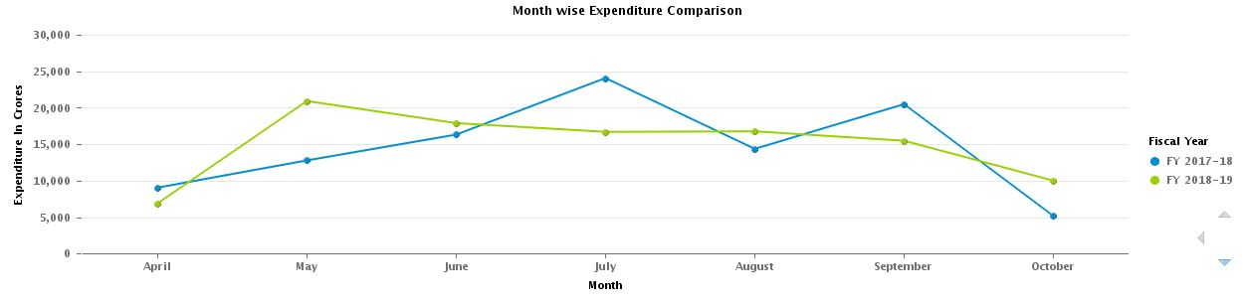

OBJECTS | OBJECT TYPE | AXIS
EXPENDITURE IN CRORES | MEASURE | VALUE AXIS 1
MONTH | DETAIL | CATEGORY AXIS
FISCAL YEAR | DETAIL | REGION COLOR

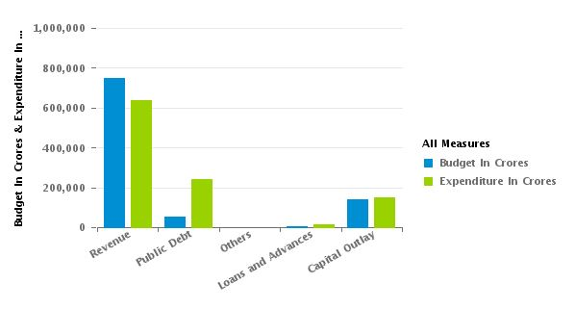

OBJECTS | OBJECT TYPE | AXIS
RH_HOA_SUB_CAT | DIMENSION | CATEGORY AXIS
BUDGET IN CRORES | MEASURE | VALUE AXIS 1
EXPENDITURE IN CRORES | MEASURE | VALUE AXIS 1

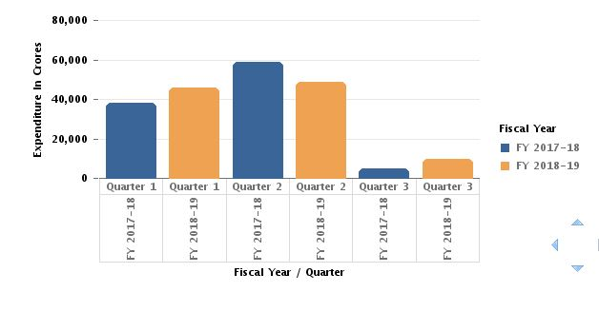

OBJECTS | OBJECT TYPE | AXIS
EXPENDITURE IN CRORES | MEASURE | VALUE AXIS 1
QUARTER | DETAIL | CATEGORY AXIS
FISCAL YEAR | DETAIL | CATEGORY AXIS
FISCAL YEAR | DETAIL | REGION COLOR

8.7 Expenditure Report with HOA Level:
After expanding the Hierarchies under the Expenditure Column, we would see a HOA hyperlink adjacent to the Expenditure Column, as per screen shot below.

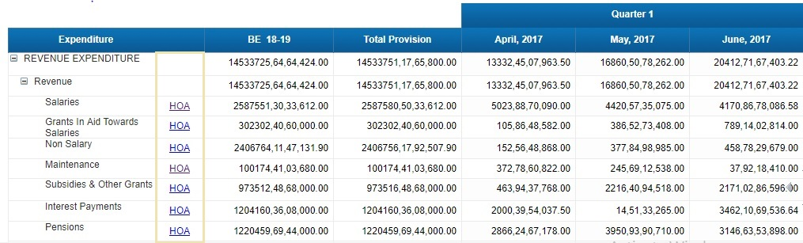
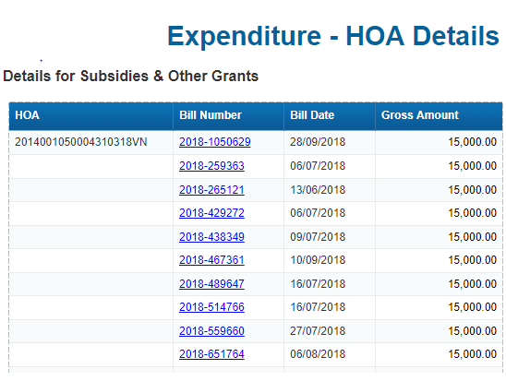

By clicking on a Particular HOA Hyperlink a detail report with respect to Subsidies & Other Grants are generated.

After Clicking on the required Bill Number, next page is displayed.

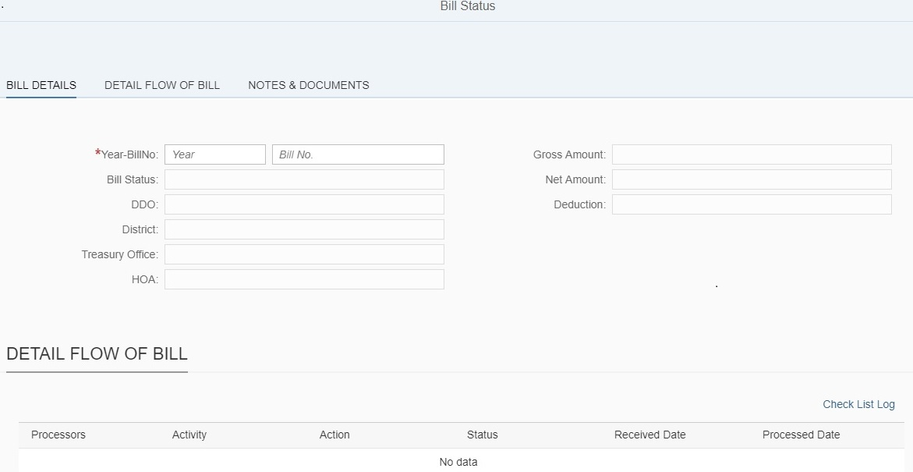

Expenditure Summary and Expenditure Month/Quarter wise comparison and HOA Report Level User Prompts & Input Controls used:
- User Prompts are not used in the Expenditure Summary Report.

- There are Three Input Controls used in the Expenditure Summary Report.
- Currency Scaling
- Fiscal Year Filter
- Comparison.

- There are Four User Prompts used in the HOA Report.
- HOA Category
- HOA Sub Category
- HOA Sub Sub Category
- Fiscal Year

- There are Four Input Controls used in the HOA Report.
- Currency Scaling
- From Date
- To Date
- HOA- Major Head,Sub Major Head,Minor Head,Sub Head,Group Sub Head,Detailed Head,Sub Detailed Head.

Appendix A

Appendix B

